موضوع تحقیق : چند سوال تاریخ : 20/09/1404
استاد راهنما : دکتر سجاد فرخی
گرد آورنده : علیرضا کاروی
- در بخش اول opening انجام میده چرا دیگه closing نیاز هست؟!
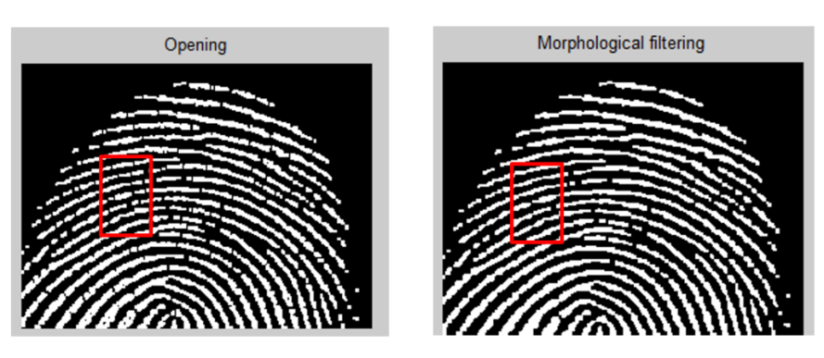
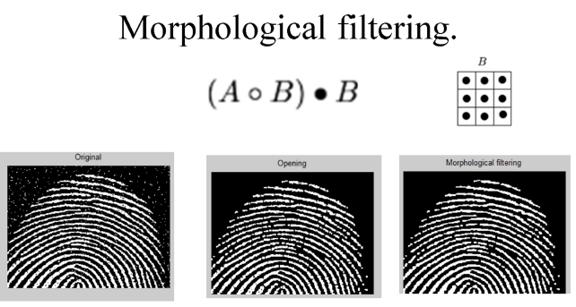
- ……………………………………………………………………………………………………………………………………………………………………………………………………………………………………………………………………………………………………………………………………………………………………………………………………………………………………………………………………………………………………………………………………………………………………………………………………………………………………………………………………………………………………………………………………………………………………………………………………………………………………………………………………………………………………………………………………………………………………………………………………………………………………………………………………………………………………………………………………………………………………………………………………………………………………………………………………………………………………………………………………………………………………………………………………………………………………………………………………………………………………………………………………………………………………………………………………………………………………………………………………………………………………………………………………………
- تحقیق درباره چرا دایره دور این خط نازک سفیده حذف شده

- ………………………………………………………………………………………………………………………………………………………………………………………………………………………………………………………………………………………………………………………………………………………………………………………………………………………………………………………………………………………………………………………………………………………………………………………………………………………………………………………………………………………………………………………………………………………………………………………………………………………………………………………………………………………………………………………………………………………………………………………………………………………………………………………………………………………………………………………………………………………………………………………………………………………………………………………………………………………………………………………………………………………………………………………………………………………………

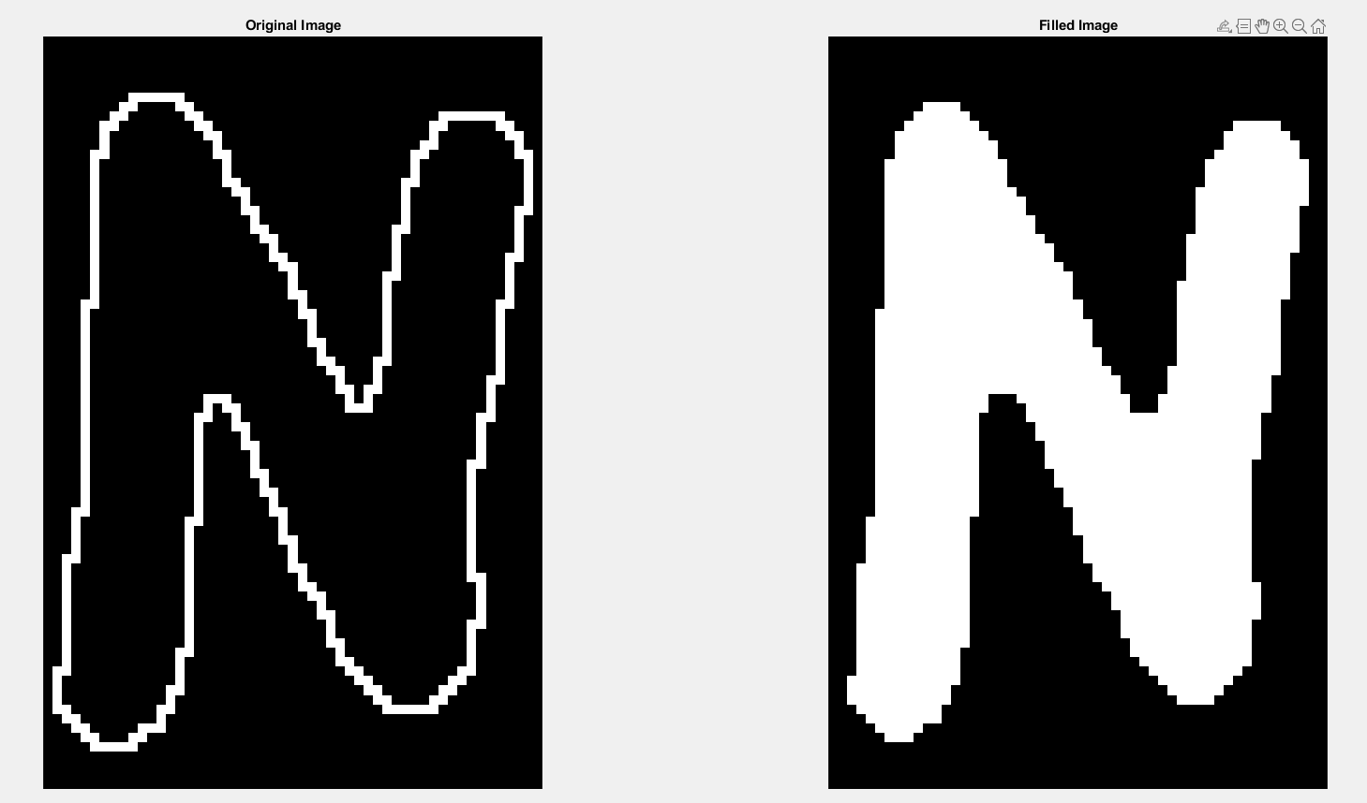
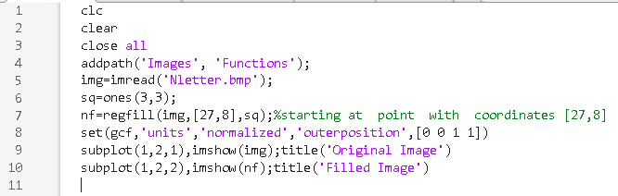
- بررسی test8_1
……………………………………………………………………………………………………………………………………………………………………………………………………………………………………………………………………………………………………………………………………………………………………………………………………………………………………………………………………………………………………………………………………………………………………………………………………………………………………………………………………………………………………………………………………………………………………………………………………………………………………………………………………………………………………………………………………………………………………………………………………………………………………………………………………………………………………………………………………………………………………………………………………………………………………………………………………………………………………………………………………………………………………………………………………………………………………………………………………………………………………………………………………………
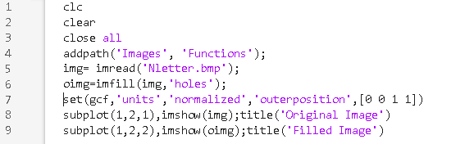
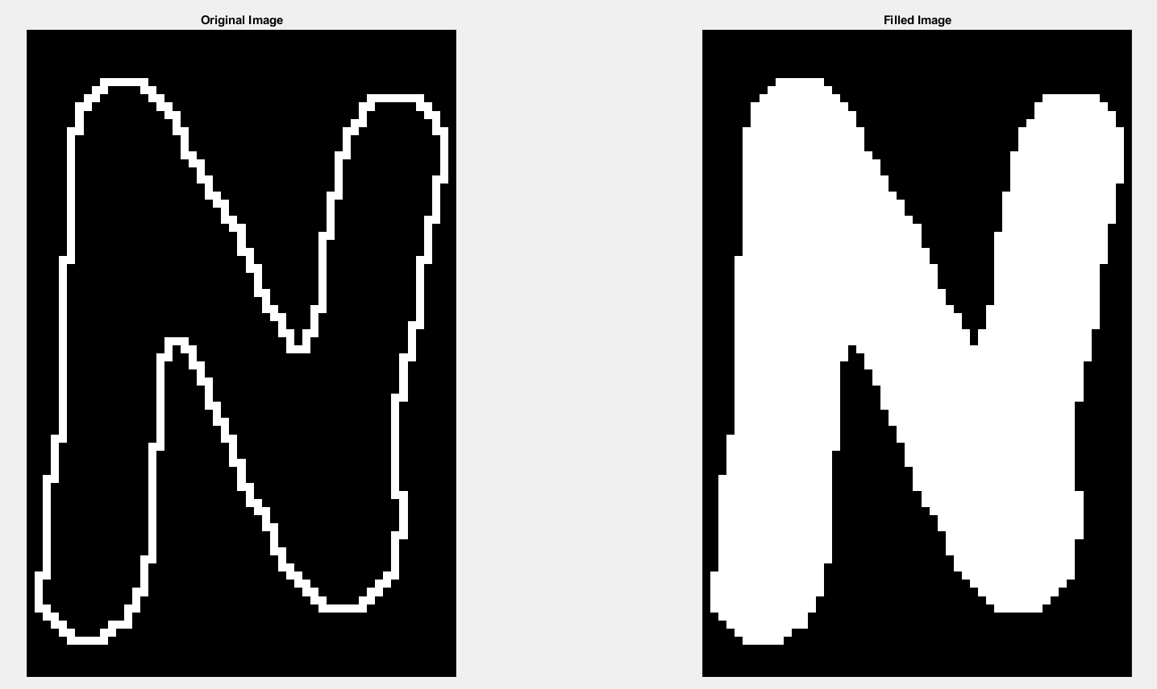
- بررسی test8_2 ………………………………………………………………………………………………………………………………………………………………………………………………………………………………………………………………………………………………………………………………………………………………………………………………………………………………………………………………………………………………………………………………………………………………………………………………………………………………………………………………………………………………………………………………………………………………………………………………………………………………………………………………………………………………………………………………………………………………………………………………………………………………………………………………………………………………………………………………………………………………………………………………………………………………………………………………………………………………………………………………………………………………………………………………………………………………………………………………………………………………………………………………………………………………………………………………………………………………………………………………………………………………………………………………………………………………………………………………………………………………………………………………………………………………………………………………………………………………………………………………

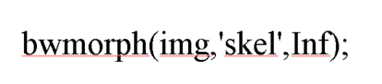
- تحقیق درباره

function [bwout,lut] = bwmorph(bwin,op,n)
%BWMORPH Morphological operations on binary image.
% BW2 = BWMORPH(BW1,OPERATION) applies a specific
% morphological operation to the binary image BW1.
%
% BW2 = BWMORPH(BW1,OPERATION,N) applies the operation N
% times. N can be Inf, in which case the operation is repeated
% until the image no longer changes.
%
% OPERATION is a string or char vector that can have one of these values:
% 'bothat' Subtract the input image from its closing
% 'branchpoints' Find branch points of skeleton
% 'bridge' Bridge previously unconnected pixels
% 'clean' Remove isolated pixels (1's surrounded by 0's)
% 'close' Perform binary closure (dilation followed by
% erosion)
% 'diag' Diagonal fill to eliminate 8-connectivity of
% background
% 'endpoints' Find end points of skeleton
% 'fill' Fill isolated interior pixels (0's surrounded by
% 1's)
% 'hbreak' Remove H-connected pixels
% 'majority' Set a pixel to 1 if five or more pixels in its
% 3-by-3 neighborhood are 1's
% 'open' Perform binary opening (erosion followed by
% dilation)
% 'remove' Set a pixel to 0 if its 4-connected neighbors
% are all 1's, thus leaving only boundary
% pixels
% 'shrink' With N = Inf, shrink objects to points; shrink
% objects with holes to connected rings
% 'skel' With N = Inf, remove pixels on the boundaries
% of objects without allowing objects to break
% apart
% 'spur' Remove end points of lines without removing
% small objects completely
% 'thicken' With N = Inf, thicken objects by adding pixels
% to the exterior of objects without connected
% previously unconnected objects
% 'thin' With N = Inf, remove pixels so that an object
% without holes shrinks to a minimally
% connected stroke, and an object with holes
% shrinks to a ring halfway between the hole
% and outer boundary
% 'tophat' Subtract the opening from the input image
%
% Class Support
% -------------
% The input image BW1 can be numeric or logical.
% It must be 2-D, real and nonsparse. The output image
% BW2 is logical.
%
% Remarks
% -------
% To perform erosion or dilation using the structuring element ones(3),
% use IMERODE or IMDILATE.
%
% Examples
% --------
% BW1 = imread('circles.png');
% figure, imshow(BW1)
% BW2 = bwmorph(BW1,'remove');
% BW3 = bwmorph(BW1,'skel',Inf);
% figure, imshow(BW2)
% figure, imshow(BW3)
%
% See also IMERODE, IMDILATE, BWEULER, BWPERIM, BWMORPH3, BWSKEL.

% The second output argument, LUT, is intentionally undocumented. In the
% initial release of the Image Processing Toolbox, all the operations
% supported by bwmorph used a single look-up table, which was returned as
% the second output argument. In subsequent releases, however, bug fixes
% and enhancements resulted in some operations no longer using a single
% look-up table. As a result, the second output argument no longer served
% the purpose envisioned in the original design of the bwmorph syntax. To
% reduce compatibility problems, the second output argument was retained
% in the code, but it has been removed from the documentation. For
% operations which do not use a single look-up table, the second output
% argument is returned as [].
………………………………………………………………………………………………………………………………………………………………………………………………………………………………………………………………………………………………………………………………………………………………………………………………………………………………………………………………………………………………………………………………………………………………………………………………………………………………………………………………………………………………………………………………………………………………………………………………………………………………………………………………………………………………………………………………………………………………………………………………………………………………………………………………………………………………………………………………………………………………………………………………………………………………………………………………………………………………………………………………………………………………………………………………………………………………………………………………………………………………………………………………………………………………………………………………………………………………………………………………………………………………………………………………………………………………………………………………………………………………………………………………………………………………………………………………………………………………………………………………………………………………………………………………………………………………………………………………………………………………………………………………………………………………………………………………………………………………………………………………………………………………………………………………………………………………………………………………………………………………………………………………………………………………………………………………………

